# COOKBOOK PROJECT REPORTS

**• Project Title:** CookbookYour Virtual Kitchen

Assistant.TeamLeademageshwaridhanush.s@gmail.co mo :

2.Afiya

3.Ezhil.J-

ZZZ

**Project Title:** CookBook-Your Virtual Kitchen Assistant.

**Team ID: NM2025TMID40576**

**Team Leader:S.**Dhanush

[**dhanub9307@gmail.com**](mailto:dhanub9307@gmail.com)

**Team Mates: R.Aravind**

**abishake072@gmail.com**

**R.MANOJ**

**alexmanoj2203@gmail.com**

**J.Barani dharan**

**baranivr2146@gmail.com**

## INTRODUCTION

Cooking is not just about preparing food—it is also an enjoyable and creative activity that brings people together. In today’s busy world, many people don’t have the time to follow traditional cookbooks or search for recipes in multiple places. Technology has made it easier to access information, and cooking is no exception. Our project, Cookbook – Your Virtual Kitchen, is designed to make cooking easier, more fun, and more accessible to everyone.

The main goal of this project is to create a digital platform where users can find recipes quickly and easily. Users can search for recipes based on the type of cuisine, ingredients they have, cooking time, or difficulty level. This makes it simple for both beginners and experienced cooks to find dishes that suit their needs. In addition, users can save their favourite recipes, customize them, and access them anytime on their devices, which adds convenience and flexibility.

We have designed the platform with a clean and easyto-use interface. Using technologies like HTML, CSS, and JavaScript, the virtual kitchen works smoothly on laptops, tablets, and smartphones. Unlike traditional cookbooks, our project allows users to interact with the content, search instantly, and organize recipes the way they want, making the whole cooking experience faster and more enjoyable.

Cookbook – Your Virtual Kitchen is more than just a collection of recipes. It is a way to bring together traditional cooking knowledge and modern technology. Through this project, we hope to encourage people to explore new dishes, learn cooking skills, and enjoy the process of preparing food. It is a practical and creative solution that shows how technology can improve daily life and make cooking a fun, engaging, and stress-free experience.

**SOURCE CODE**

import React, { useEffect } from 'react' import '../styles/CategoryPage.css' import { useNavigate, useParams } from 'react-router-dom'; import axios from 'axios'; const Category = () => { const navigate = useNavigate() const {id} = useParams(); const [items, setItems] = React.useState([]) useEffect(() => { fetchItems(id)

}, [window.location.href]) const fetchItems = async (idd) => { await axios.get(`https://www.themealdb.com/api/json/v1/1/filter.ph p?c=${idd}`)

.then(response => { setItems(response.data.meals) console.log(response.data.meals)

})

.catch(error => console.error(error));

}

return (

<div className='category-page'>

<div className="categorypage-head">

<h2>Category: <i>{id}</i></h2>

<div className='categorypage-head-options' >

<p>Other popular categories:</p>

<span>

<button onClick={()=>{ navigate(`/category/Chicken`); fetchItems('Chicken')} } >Chicken</button>

<button onClick={()=>

{navigate(`/category/Vegetarian`); fetchItems('Vegetarian')}}>Vegetarian</button>

<button onClick={()=> {navigate(`/category/Starter`); fetchItems('Starter')}}>Starter"</button>

<button onClick={()=> {navigate(`/category/Seafood`); fetchItems('Seafood')}}>Seafood</button>

<button onClick={()=> {navigate(`/category/Dessert`); fetchItems('Dessert')}}>Dessert</button>

</span>

</div>

</div>

<div className="categorypage-body">

{items ?

<div className="food-items">

{items.map((item) => (

<div className="food-item" onClick={()=> navigate(`/recipie/${item.idMeal}`)}>

<img src={item.strMealThumb} alt="food-item" />

<h4>{item.strMeal}</h4>

</div>

))}

</div>

:"Loading..."}

</div>

</div>

)

}

export default Category import Hero from '../components/Hero' import CategoriesHome from '../components/CategoriesHome' import About from '../components/About' import NewsLetter from '../components/NewsLetter' import '../styles/Home.css' const Home = () => {

return (

<div className='homepage'>

<Hero />

<CategoriesHome />

<NewsLetter />

</div>

)

}

export default Home

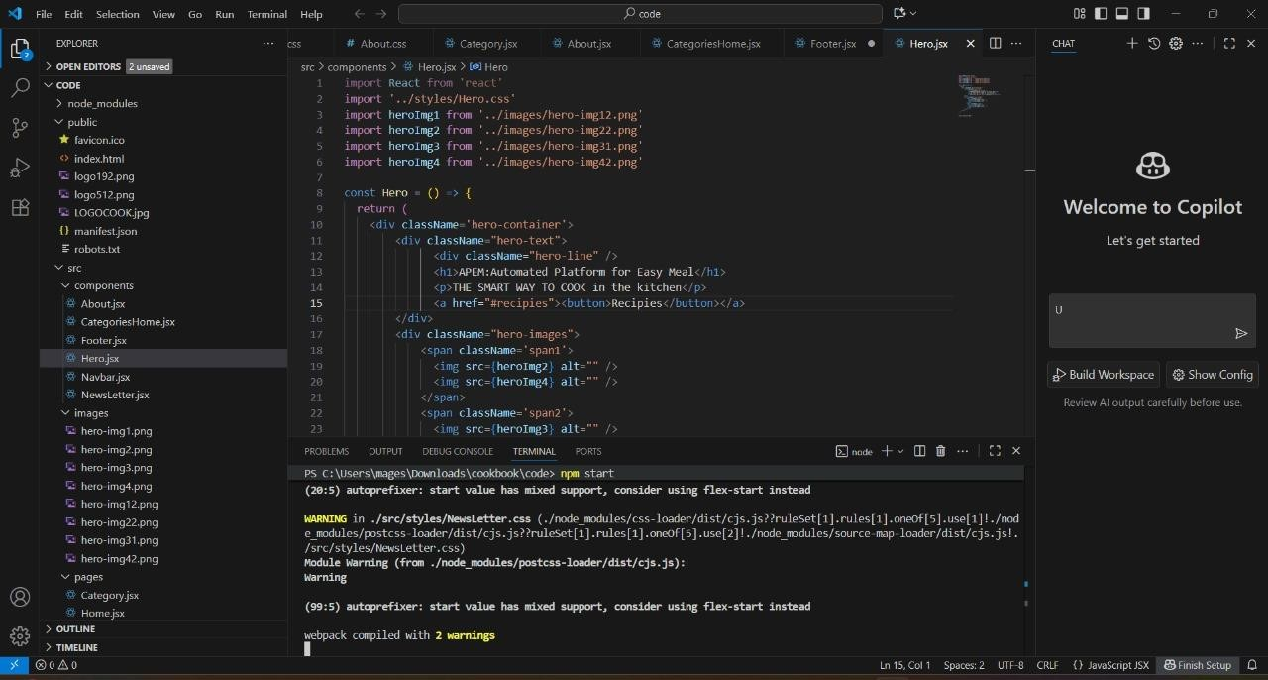

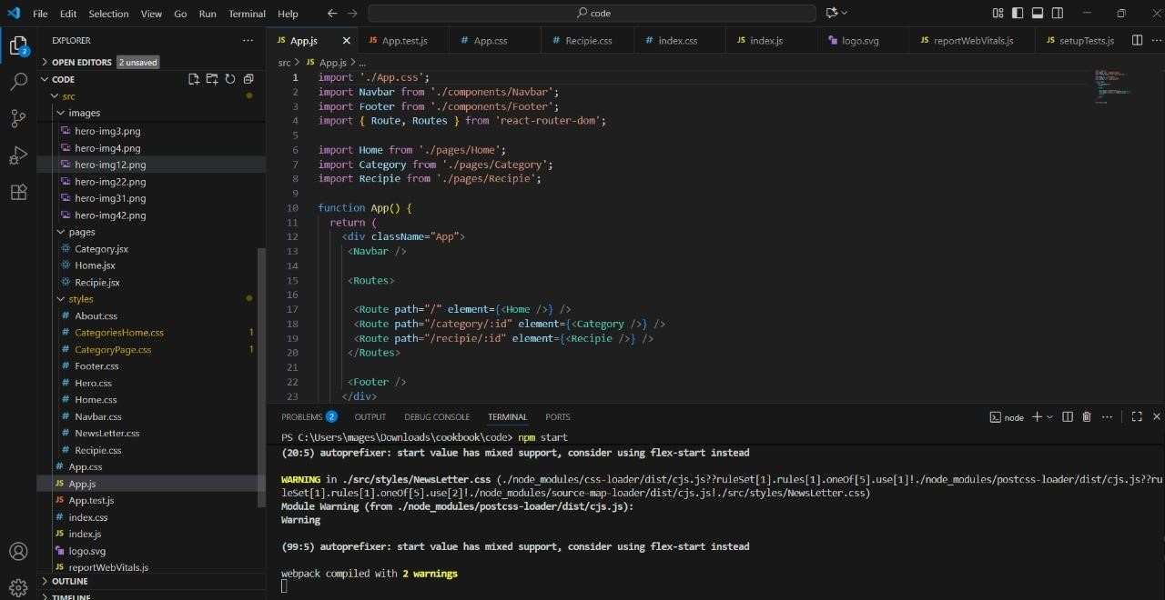

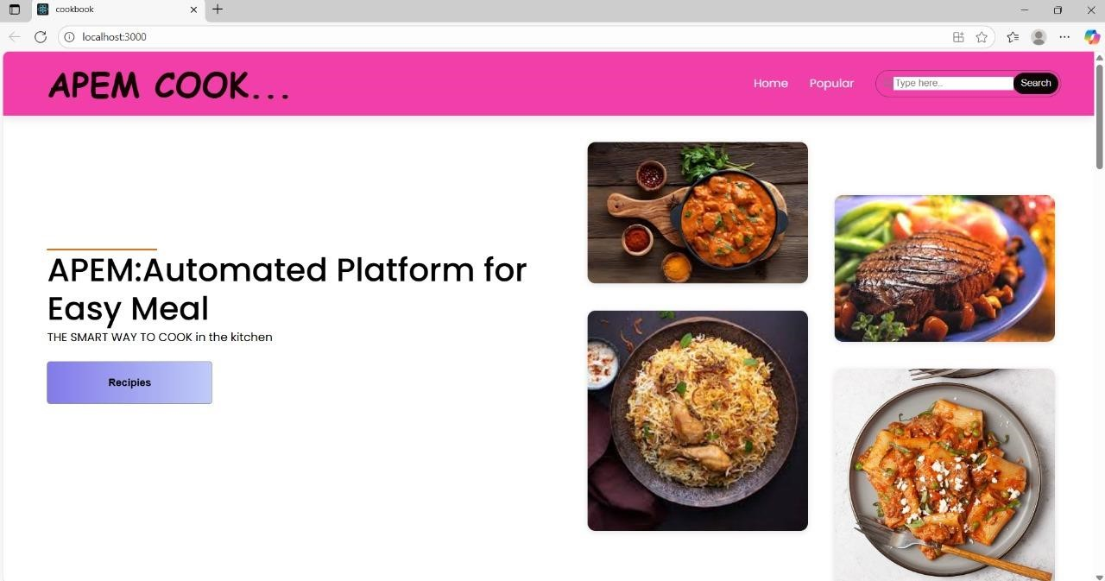

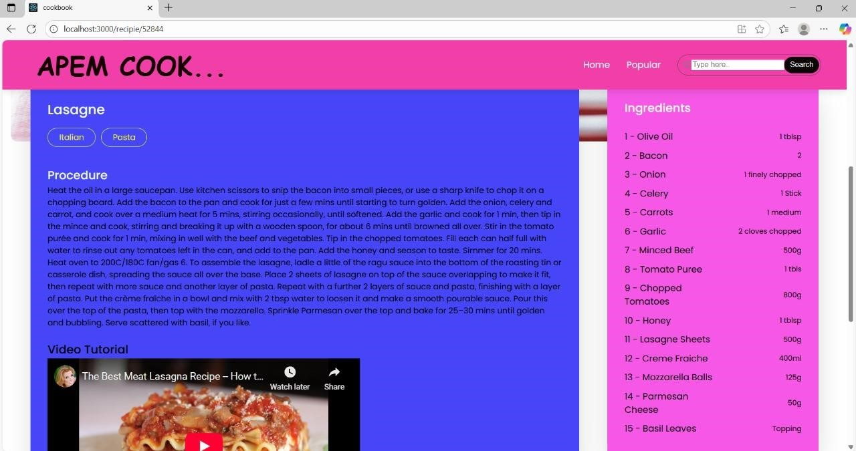

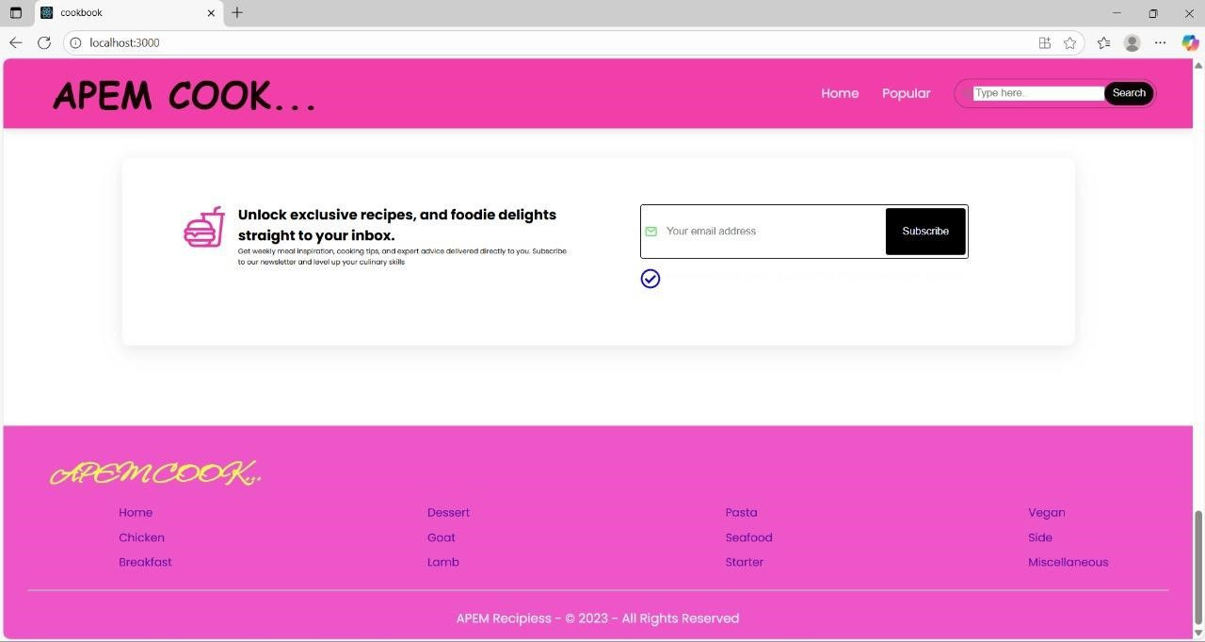

# DEMO LINK

The demo can be hosted locally by opening the HTML file in a browser. Alternatively ,it can be deployed using platforms like GitHub pages,

Netlify or vercel.Example demo link

https://1drv.ms/v/c/CE9E37E8A5AA4569/AQvui7GpJ

M9Ogfm8zjomEEw?e=mw9kgf